1. **Let’s write Unit Test for HelloWorldController.java**.  
   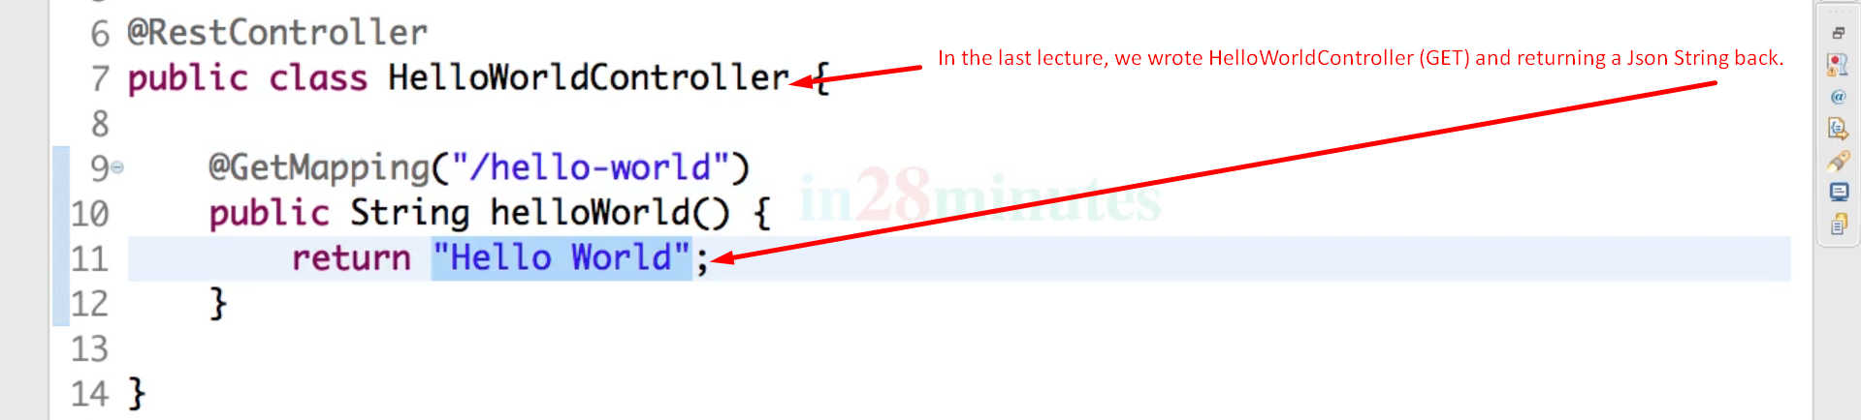
2. The main feature of **Unit Test** is that we don’t need to launch the entire app means no need to load all the controllers, Service Components other components to unit test **HelloWorldController.java**.   
   If we’re loading all of them, then it becomes **Integration Testing**.  
   This is where **Spring MockMVC** comes into picture and helps us to unit test components of Spring Boot App individually.
3. Graphical user interface, application

   Description automatically generated
4. How to unit test only HelloWorldContorller.java?
   1. one of the important things is that we want to load/lunch only HelloWorldController.java component from Spring Boot App’s all components.
   2. **Solution:** **@WebMvcTest**
   3. 
   4. **@RunWith**(**SpringRunner.class**):
      1. To enable Spring Boot features like @Autowire, @MockBean during Junit Testing.
   5. **MockMvc**:
      1. Main Entry point for Server-Side Spring MVC Test Support.
      2. It encapsulates all Web application beans and make them available for testing.
   6. Graphical user interface, text

      Description automatically generated